**Assisted Practice: 3.3 Class and Style Bindings**

This section will guide you to:

* Implement attribute, class, and style binding

This lab has four subsections, namely:

3.3.1 Disabling a button using attribute binding

3.3.2 Implementing class binding

3.3.3 Implementing style binding

3.3.4 Pushing the code to Github repositories

**Step 3.3.1:** Disabling a button using attribute binding

* Disable a button using *disabled* attribute of the element. Set the *disabled* to *false* by binding value to *attr.disabled* attribute property.
* Open Visual Studio Code
* Add the following code to *Product-list.component.html*.

<button [attr.disabled]=”true” class="btn btn-primary" (click)='toggleImage()'>

Show Image

</button>

**Output:**

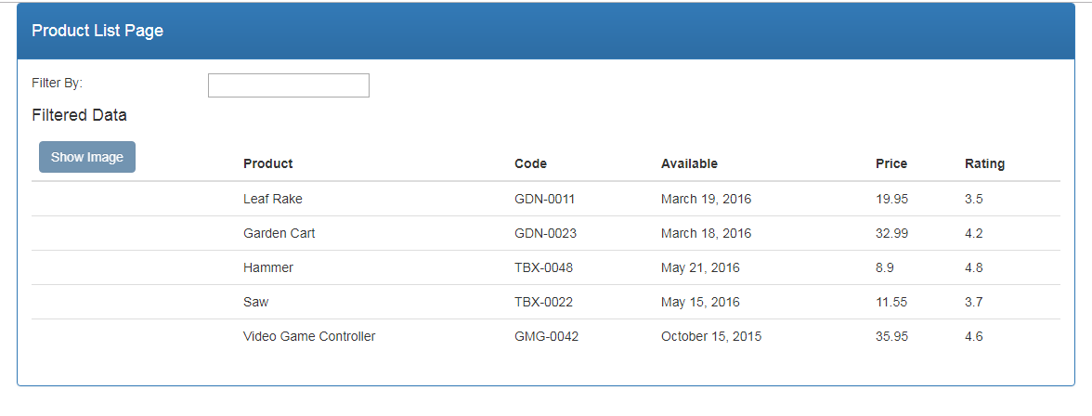

**Step 3.3.2:** Implementing class binding

* Create an external CSS file *product-list.component.css* inside *products* folder.
* Create a CSS class name *price*.

.inStock{

background: #096d09;

color:#ffff;

Font-size:15px;

}

* Apply the CSS class in *Product-list.component.html* file and set its value to *true*.

<td [class.inStock]="true">

{{ product.price}}

</td>

**Output:**

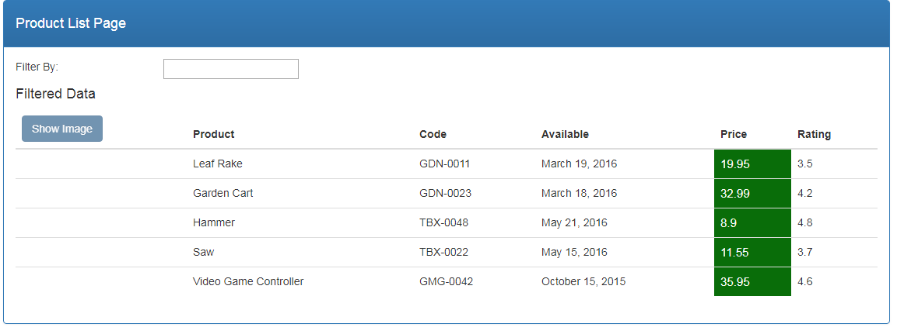

* Set class value to *false* in *Product-list.component.html*.

**Output:**

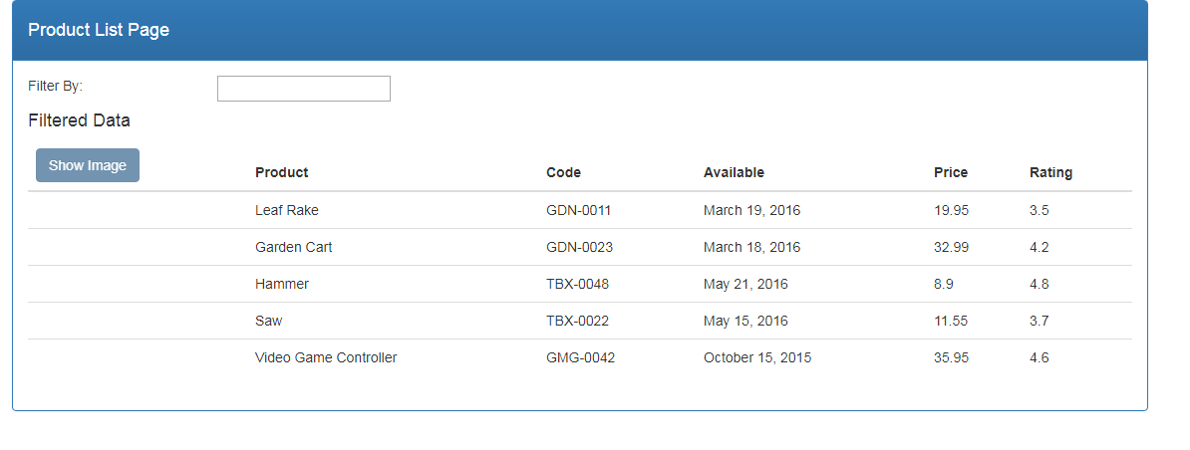

**Step 3.3.3:** Implementing style binding

* Bind a color and font-weight style to the product element in *Product-list.component.html* file.

<td [style.color]="'#306A9D'" [style.font-weight]="700">

{{ product.productName }}

</td>

**Output:**

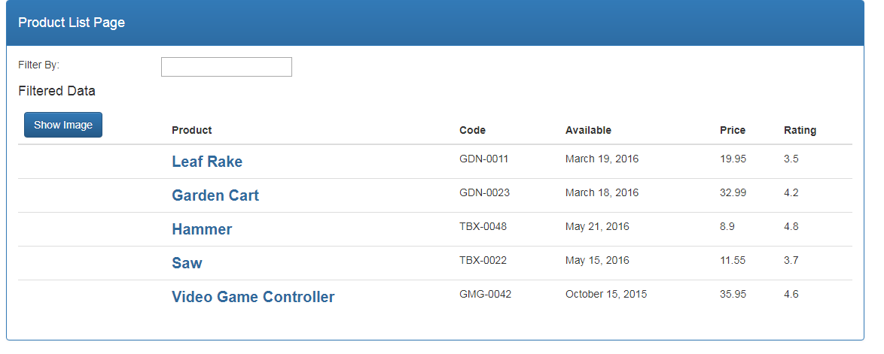

* You can also apply conditional CSS using style binding.

<td [style.color]="product.price > 20 ? 'red': 'green'" [style.font-size.px]="16" [style.font-weight]="700">

{{ product.price}}

</td>

**Output:**

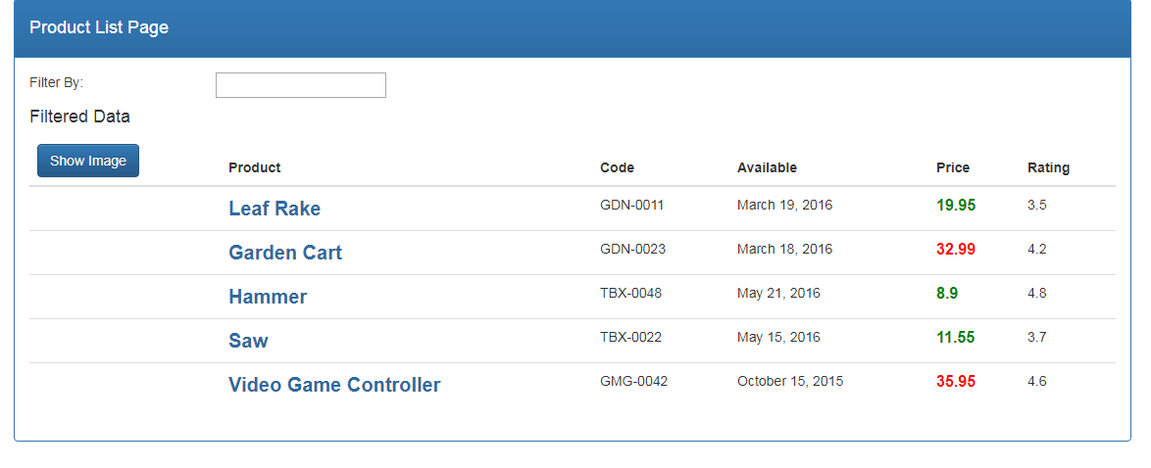

**Step 3.3.4:** Pushing the code to your GitHub repositories

* Open your command prompt and navigate to the folder where you have created your files.

**cd <folder path>**

* Initialize your repository using the following command:

**git init**

* Add all the files to your git repository using the following command:

**git add .**

* Commit the changes using the following command:

**git commit . -m “Changes have been committed.”**

* Push the files to the folder you initially created using the following command:

**git push -u origin master**